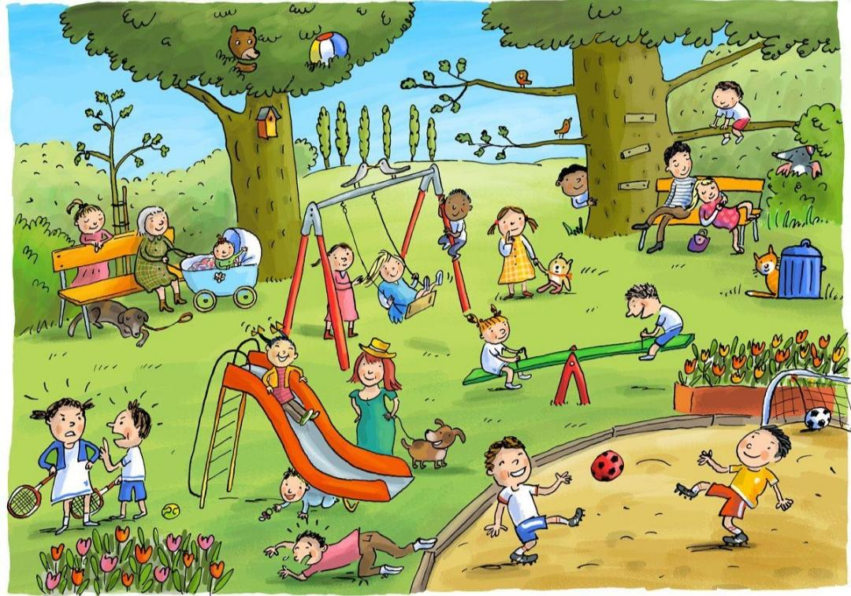
Look at the picture and write:
- One sentence with 4 masculine nouns.
- One sentence with 4 feminine nouns.
- One sentence with 4 singular nouns.
- One sentence with 4 plural nouns.
Singular–Plural Hunt
- Find things that appear one and things that appear more than one.Make a list of that.
Gender Hunt
- From the picture , write 5 pairs of masculine and feminine nouns.
Verb Detective
- Look at the picture and find all the verbs you can find. Make 5 sentences with the action words .

